

University of Westminster

Project Report Monkey Pox Testing Analysis

Data Mining and Machine Learning (7BUIS008W)

Coursework 1

B Gayan Kalinga - w2027429 – 20231057 - [gayan.20231057@iit.ac.lk](mailto:gayan.20231057@iit.ac.lk)

# Task 01: Domain Understanding Classification

1. Mark the variables logically applicable in the classification modeling of MPOX.

|  |  |
| --- | --- |
| Attribute Name | Retain or drop |
| Test ID | Drop |
| Systemic Illness | Retain |
| Sore Throat | Retain |
| Rectal Pain | Retain |
| Penile Oedema | Retain |
| Oral Lesions | Retain |
| Solitary Lesion | Retain |
| Swollen Tonsils | Retain |
| HIV Infection | Retain |
| Red blood cells | Drop |
| White blood cells | Drop |
| Home Ownership | Drop |
| Age | Retain |
| Month of Birth | Drop |
| Health Insurance | Drop |
| Sexually Transmitted Infection | Retain |
| MPOX | Retain |

# Task 02: Producing Your Experimental Design

1. Screenshots of the code output

Basic Statistical Descriptions

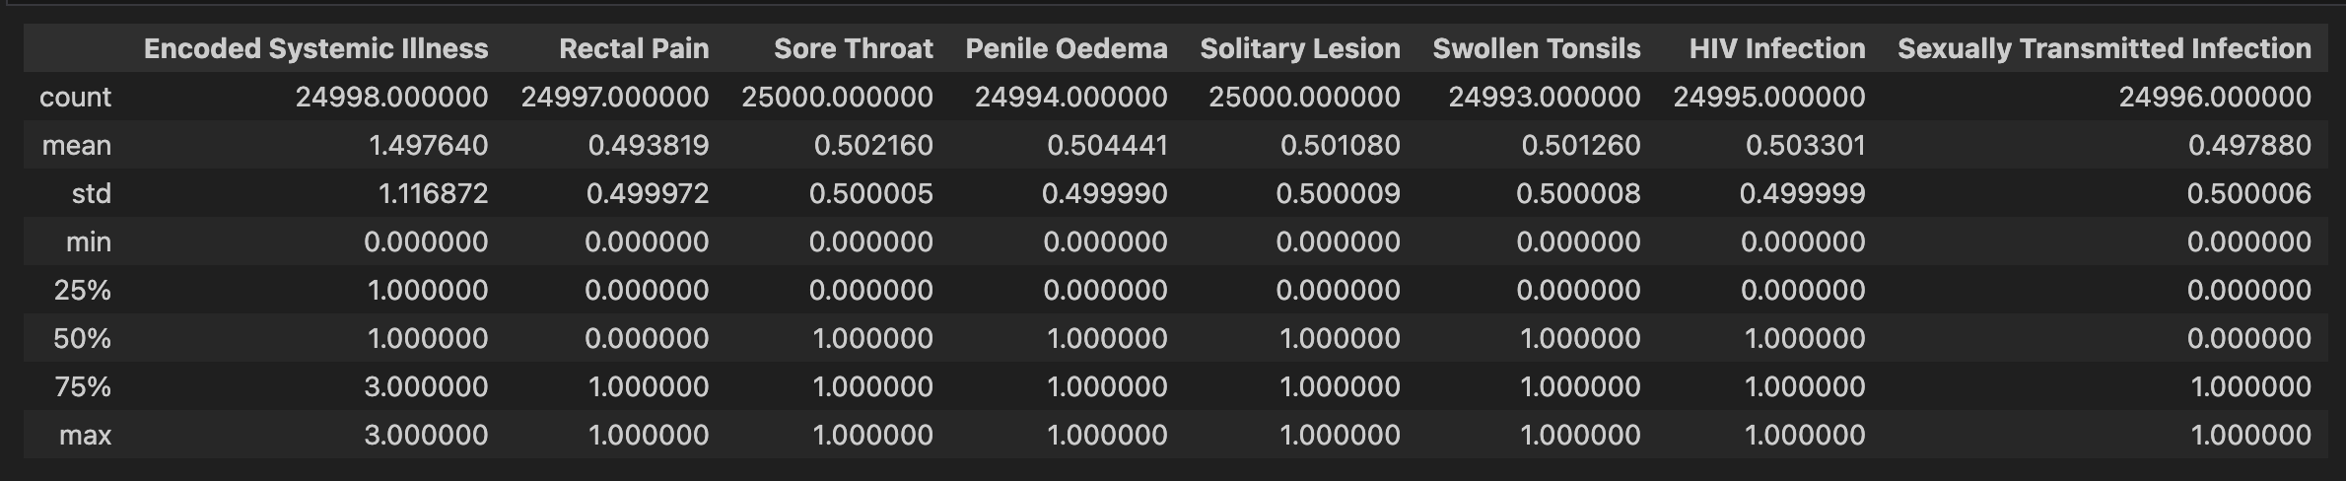

Measurement Scale Types

Distribution of the Result

# Task 03: Cleaning and Transforming the Data

1. Issues identified in the retained data set and possible variables.

|  |  |  |
| --- | --- | --- |
| Dataset or Variable Issue | Name of the Variable | Issue Description |
| Variable Issue | Encoded Systemic Illness | Missing 2 records NaN values |
| Variable Issue | Rectal Pain | Missing 3 Records NaN values |
| Variable Issue | Penile Oedema | Missing 6 records NaN values |
| Variable Issue | Oral Lesions | Missing 15 records of data, 4 records NaN values and 7 records with value No and 4 records with value Yes |
| Variable Issue | Swollen Tonsils | Missing 7 records NaN values |
| Variable Issue | HIV Infection | Missing 5 records NaN values |
| Variable Issue | Age | Issues in 42 records, 36 records NaN values, 1 value with string twenty, having 1 minus value -23 and 4 outliers from 18 to 61 range |
| Variable Issue | Sexually transmitted infection | Missing 4 records NaN values |
| Variable Issue | MPOX PCR Result | Using Negative & Positive as string values |
| Dataset issue | Whole Dataset | 4100 duplicate records found when the ‘Test ID’ column was dropped |

1. Solution to mitigate issues found with justification for using that solution.

|  |  |  |  |  |
| --- | --- | --- | --- | --- |
| Dataset or Variable Issue | Name of the Variable | Issue Description | Solution | Justification |
| Variable Issue | Encoded Systemic Illness | Missing 2 records NaN values. | Imputation to replace the NaN with most frequent (mode) value. | When the affected records are smaller in comparison this is a good strategy to avoid loss of data which may be crucial for classification. |
| Variable Issue | Rectal Pain | Missing 3 Records NaN values. | Imputation to replace the NaN with most frequent (mode) value. | When the affected records are smaller in comparison this is a good strategy to avoid loss of data which may be crucial for classification. |
| Variable Issue | Penile Oedema | Missing 6 records NaN values. | Imputation to replace the NaN with most frequent (mode) value. | When the affected records are smaller in comparison this is a good strategy to avoid loss of data which may be crucial for classification. |
| Variable Issue | Oral Lesions | Missing 15 records of data, 4 records NaN values and 7 records with value No and 4 records with value Yes  2 string values 0.0 converted to int. | Imputation to replace 15 records of NaN with most frequent (mode) value. Converted the string values to numeric with Yes = 1 and No = 0 also converted the 0.0 string value to 0 and 1.0 string to numeric values. | When the affected records are smaller in comparison this is a good strategy to avoid loss of data which may be crucial for classification. Converted the string to numerical to facilitate the machine learning inputs. To get higher quality dataset. |
| Variable Issue | Swollen Tonsils | Missing 7 records NaN values. | Imputation to replace the NaN with most frequent (mode) value. | When the affected records are smaller in comparison this is a good strategy to avoid loss of data which may be crucial for classification. |
| Variable Issue | HIV Infection | Missing 5 records NaN values. | Imputation to replace the NaN with most frequent (mode) value. | When the affected records are smaller in comparison this is a good strategy to avoid loss of data which may be crucial for classification. |
| Variable Issue | Age | Issues in 42 records, 36 records NaN values, 1 value with string twenty, having 1 minus value -23 and 4 outliers from 18 to 61 range. | Imputation to replace 36 records the NaN with most frequent (mode) value.  String value is converted to numeric value, minus value is converted to plus value using absolute function. 4 records not within the range based on the scatter plot removed from the dataset. | When the affected records are smaller in comparison this is a good strategy to avoid loss of data which may be crucial for classification.  Converted the string to numerical to facilitate the machine learning inputs. To get higher quality dataset. dropped the outliers, this to ensure higher quality data set which will increase the efficiency and accuracy of the models. |
| Variable Issue | Sexually transmitted infection | Missing 4 records NaN values. | Imputation to replace the NaN with most frequent (mode) value. | When the affected records are smaller in comparison this is a good strategy to avoid loss of data which may be crucial for classification. |
| Variable Issue | MPOX PCR Result | Using Negative & Positive as string values. | Converted using the mapping to positive = 1 and negative = 0. | Classification algorithms require numerical data hence to facilitate efficient model training and evaluation converted to the numerical. |
| Dataset issue | Whole Dataset | 4100 duplicate records found when the ‘Test ID’ column was dropped. | No action. | Since the duplicate record appear only after dropping the primary id column ‘Test ID’ this should be a false positive. |

1. Outputs (Before & After)

|  |  |
| --- | --- |
| Before | After |
| 1. Cleaning the missing values using the imputation for all variables | |
|  |  |
| 1. Fixing Oral Lesions Yes/No values and unique value issues | |
|  |  |
| 1. Fixing the Age-related issues | |
|  |  |
| 1. Converting the MPOX PCR Result to numeric values | |
|  |  |
| 1. Duplicate Records | |
|  |  |
| 1. Full Dataset information | |
|  |  |

# Task 04: Create Predictive Classification Models

1. Classification algorithm details

|  |  |  |  |  |
| --- | --- | --- | --- | --- |
| Algorithm Name | Type of Algorithm | Learnable Parameters | Possible Hyper – Parameters | Python package source code to call the algorithm |
| LR | Parametric | CoefficientsWeights for features and intercept | `solver=’liblinear’ `penalty=’L2’` | `sklearn.linear_model`  `import LogisticRegression` |
| DT | Non-parametric | Splitting rules for nodes, decision rules based on features | `max_depth=5` `min_samples_split=4` `min_samples_leaf=2` `criterion=’entropy` | `sklearn.tree`  `import DecisionTreeClassifier` |
| KNN | Non-parametric | Training Dataset | `n_neighbors=2` `metric=’minkowski` | `sklearn.neighbors`  `import KneighborsClassifier` |
| SVM (RBF) | Non-parametric | Support vectors, weights for features | `C=2`  `kernal=’rbf’` | `sklearn.svm`  `import SVC` |
| NB | Parametric | Prior probabilities for classes and Features | `var_somoothing=1e-10` | `sklearn.naive_bayes`  `import GaussianNB` |

1. Data shape function output
2. List of features used to train the model and the X and y data shape, in this case Y data shape does not show the column count.

1. Justify the training-test split ratio and provide an in-text reference.

The choice of the training-test split ratio is a critical aspect of model evaluation, greatly influencing the model's ability to generalize to unseen data (Provost & Fawcett, 2013). In this scenario, a split ratio of 80% training data and 20% testing data was selected for several reasons. Firstly, allocating a larger proportion of the data to training (80%) allows the model to learn more intricate patterns and relationships within the dataset, potentially enhancing its robustness. Secondly, with 20% reserved for testing, there is ample unseen data to comprehensively assess the model's performance without compromising the adequacy of the training set.

This split ratio strikes a balance between the size of the training and testing sets, aiming to mitigate issues such as overfitting or underfitting. Such a decision aligns with established best practices in machine learning, where common split ratios include 70/30, 80/20, or 75/25, tailored to the size and characteristics of the dataset (James et al., 2013, p. 186). The 80/20 split, though slightly different from the stated 75/25, remains widely recommended and has demonstrated success in various studies. It ensures a sufficiently large training set for effective model learning while reserving a substantial test set for robust model evaluation.

1. Code line from the source code.



1. MPOX positive-negative ratios (positive = 1 and negative = 0)

# Task 05: How Good Is the Model

1. Test confusion matrix for each trained model (output screenshots)

|  |  |
| --- | --- |
| Logistic Regression | Decision Tree Classifier |
|  |  |
| K-nearest Neighbor | Support Vector machines with RBG |
|  |  |
| Naïve Bayes |  |
|  |  |

1. Five different classification evaluation metrics

|  |  |  |  |  |
| --- | --- | --- | --- | --- |
| Metric Name | “USE” or “DO NOT USE” | Justification in relation to the success criteria | Model Name | Metric Score |
| Accuracy | DO NOT USE | Since the model should predict as many positive subjects as possible and it could treat false positives and false negatives equally which is not align with the success criteria. | LR | 0.6726 |
| DT | 0.6758 |
| KNN | 0.6576 |
| SVM (RBF) | 0.6882 |
| NB | 0.6728 |
| Recall | USE | Since importance of correctly detecting MPOX positive subjects by focusing on the true positive rate, which aligns with the success criteria | LR | 0.8966 |
| DT | 0.8456 |
| KNN | 0.7831 |
| SVM (RBF) | 0.9179 |
| NB | 0.9047 |
| Precision | USE | Since this evaluates the correctness of positive predictions and to ensure the predicted MPOX positive subjects are correct, and this align with the success criteria. | LR | 0.6856 |
| DT | 0.7942 |
| KNN | 0.7091 |
| SVM (RBF) | 0.6923 |
| NB | 0.6835 |
| F-Measure | USE | Since this score consider both precision and recall, provides a comprehensive evaluation. Since the success criteria involved with both recall and precision this provides a comprehensive look. | LR | 0.6576 |
| DT | 0.7685 |
| KNN | 0.7443 |
| SVM (RBF) | 0.7893 |
| NB | 0.7787 |
| AUC-ROC | DO NOT USE | Since this does not directly address the specific success criteria provided | LR | 0.5885 |
| DT | 0.6120 |
| KNN | 0.6104 |
| SVM (RBF) | 0.6020 |
| NB | 0.5857 |

1. Best classification model or model and description of how this model satisfiesthe needs of your healthcare professionals.

Based on the selected USED success criteria and model evaluation metrics, I would recommend the Support Vector Machine (SVM) with RBF Kernel model. The SVM has the highest recall score of 0.9179, which relates with detecting as many true MPOX positive cases as possible. Combined with strong precision of 0.6923, meaning good portion of its positive predictions are correct. Finally showing the balancing in both recall and precision using F1-score of 0.7893.

In comparison with the other models

1. LR and DT has slightly lower recall and F1-score
2. KNN has poor scores in all three metrics.
3. NB is comparable to SVM but has slight slower scores in all three metrics.

The SVM with RBF satisfies the healthcare professionals needs, so they would be able to identify patients with positive MPOX effectively (high recall). Also, SVM provides strong precision even though this is not the highest they strike a good balance so healthcare professionals can trust that when the model predicts a patient, he/she is MPOX positive. SO, I would recommend the team to use SVM with RBK kernel for predicting which subjects needs further PCR testing.

1. Results after tuning the hyper parameters for SVM modle with RBF Kernel
2. Number of cross-validation K folds used is 10 for each of 16 candidates totaling 160 fits and following are the best Hyper-parameters: {
   * 1. 'C': 100,
     2. 'gamma': 0.1,
     3. 'kernel': 'rbf'}
3. Test Confusion Matrix

[[558 1260]

[288 2894]]

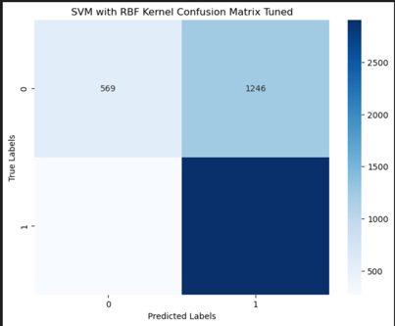

1. Selected Used Test Scores for Tuned SVM Model:

* Recall: 0.9094
* Precision: 0.6966
* F1-Score: 0.7889

1. Explain your observations

Hyperparameter tuning has led to marginal decline in recall and F1-scores and slight increase in the precision scores. This suggests that the tuned model is almost the same at correctly classifying instances across all classes, However the changes in precision minimal incidcating that the model performance did not drastically change after tuning. So this indicate that the original model was already performing at the best. Hence further improvements may requires other approches or more extensive hyperparameter tuning.

1. Creating Ensemble Voting Learner
2. Specify your reasoning behind the choice of both base learners.

Based on their performance and diversity to maximize the ensemble’s performance.

SMV with RBF Kernel is chose due to this model showed the best performance in terms of, recall, precision and F1-score so that it provides strong, stable prediction for MPOX positive cases.

Naïve bayes is chosen even though it is not a top performer it still showed good performance scores metrics and offers different learning approach compared to SVM adding diversity to the ensemble voting learner.

Ensemble model was created using the hard voting, Hard voting in ensemble learning combines the predicted classes of base learners by majority voting. Each base learner contributes one vote, and the class with the most votes is selected as the final prediction. This approach is suitable for models that provide discrete class predictions, such as Decision Trees and Support Vector Machines

1. Using test confusion matrices, explain if any performance improvements

Ensemble model performance metrics

* Recall: 0.8519
* Precision: 0.7089
* F1-Score: 0.7739

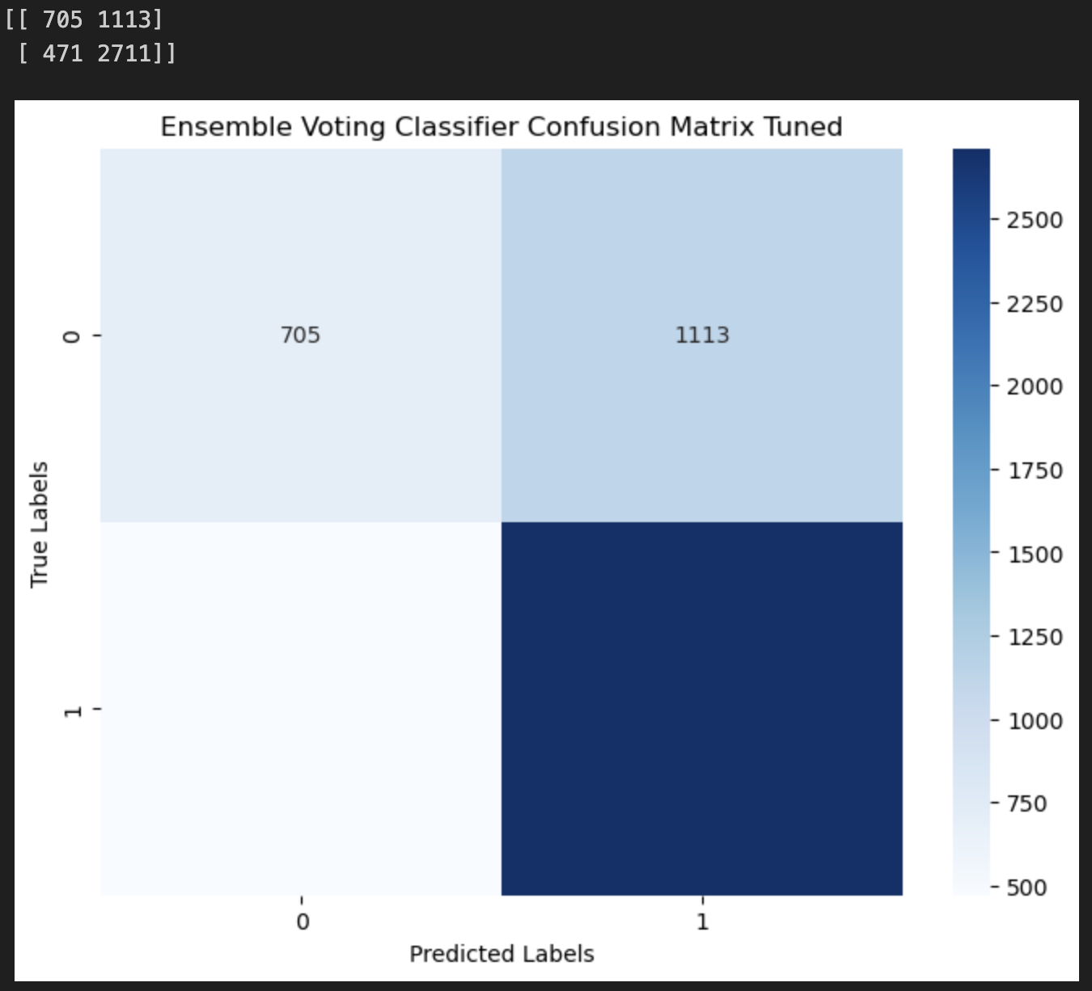

The observation are the Ensemble Voting Classifier achieved a Recall of 0.8519, Precision of 0.7089, and F1-Score of 0.7739. In comparison, the Tuned SVM Model achieved a Recall of 0.9094, Precision of 0.6966, and F1-Score of 0.7889.

The Tuned SVM Model shows slightly higher Recall and F1-Score compared to the Ensemble Voting Classifier, indicating better performance in correctly identifying positive cases. However, the Ensemble Voting Classifier demonstrates a slightly higher Precision, suggesting it is better at avoiding false positives. Both models exhibit decent performance, with the Tuned SVM Model having a slight edge in overall effectiveness

1. Anwer for the research question

**Answer to Research Question:** This research aimed to create cost-effective MPOX screening tool using machine learning based on a historical data. I have successfully tuned the SVM with RBF kernel to achieve this purpose. This tuned model achieves a recall of 0.9094, precision of 0.6966 and F1-score of 0.7889, demonstrating models’ capabilities as an alternative to lab-based tests.

**Reason for Algorithm Selection:** The SVM with RBF kernel likely outperformed other models due to its capacity to capture complex, non-linear relationships among features. Handling both categorical and numerical data effectively, it's ideal for datasets like MPOX prediction with diverse feature types. By mapping data into a higher-dimensional space, it creates intricate decision boundaries, enhancing accuracy by capturing subtle feature interactions. This likely led to its superior performance compared to other models.

**Criticism:** Critics may raise concerns about the model's reliance on historical data, potentially limiting its adaptability to evolving MPOX strains. The model's complexity and interpretability pose implementation challenges, requiring careful consideration. Effectiveness could be influenced by dataset representativeness and biases, necessitating robust data collection and continuous model validation for continued success and accuracy.

**Ethical Issues:** Deploying this screening tool raises issues of informed consent, patient privacy, and the responsible handling of sensitive health data. False positives will lead to unnecessary social issues on individuals while false negatives may pose a public health issue.

In conclusion SVM with RBK kernel model tuned with hyper parameters offers a good solution to the requirement of affordable and rapid MPOX screening tool.